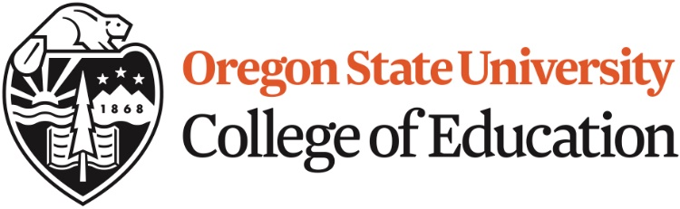

Umpqua Community College - UCC
Transfer Guide to Oregon State University’s Education Double Degree

The following courses at UCC are equivalent to courses for OSU’s Education Double Degree Program:

- ED 200 Foundation of Education = ED 216
- ED 209 Theory & Practicum = ED 309
- ED 229 Learning & Development = ED 253
- ED 258 Multicultural Education = ED 219

The following courses are great options at UCC for students preparing to teach early childhood or elementary education:

- Credits of Writing WR 121, WR 122, or WR 227
- Credits of Speech Any SP course
- Credits of English Literature Any 2 ENG courses
- US History course HST 201, 202, or 203
- World Geography course GEOG 101
Fundamentals of Elementary Math MTH 211, 212, and 213
3 Science courses w/ lab 1 General Biology course: BI 101
1 Physical Science course: GS 104, 105,
106, 107
1 Geology course: G 201, 202, 203
Any 3 credit Music, Art or Theatre Arts course

Students planning to teach middle or high school should take courses in the subject that they way to teach (ex. History, Sciences, Maths, Language arts)

For more information, please review Oregon State’s education website
education.oregonstate.edu

Phone or on-campus appointments can also be made with an OSU Double Degree academic advisor by calling 541-737-4661.

