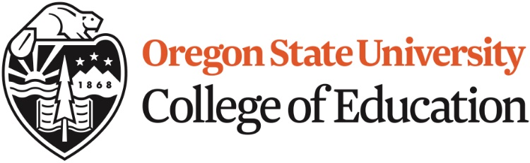

Linn Benton Community College -LBCC
Transfer Guide to Oregon State University’s Education Double Degree

The following courses at LBCC are equivalent to courses for OSU’s Education Double Degree Program:

- ED 216 Purpose, Structure & Function of Education in Democracy = ED 216
- ED 219 Multicultural Education = ED 219

The following courses are great options at LBCC for students preparing to teach early childhood or elementary education:

- Credits of Writing WR 121, WR 122, or WR 227
- Credits of Speech Any COMM course
- Credits of English Literature Any 2 ENG courses
- US History course HST 201, 202, or 203
- World Geography course GEOG 202, 203 or 204
Fundamentals of Elementary Math MTH 211, 212, and 213
3 Science courses w/ lab 1 General Biology course: BI 101
1 Physical Science course: GS 104 or GS 106
1 Geology course: G 101 or G102
Any 3 credit Music, Art or Theatre Arts course

Students planning to teach middle or high school should take courses in the subject that they way to teach (ex. History, Sciences, Maths, Language arts)

For more information, please review Oregon State’s education website
education.oregonstate.edu

Phone or on-campus appointments can also be made with an OSU Double Degree academic advisor by calling 541-737-4661.

