Requested Supplement to the Oregon State University 2007 Report:

Results of the Teacher and Counselor Education Graduate Employer Survey

College of Education
100 Education Hall

Corvallis, Oregon
97331-2140

Report Submitted for NCATE: 2007

Executive Summary

In Winter term of 2007, the faculty of the College of Education surveyed the employers of its recent graduates working in Oregon’s communities to gain important information for program evaluation and needs assessment. This survey was intended to gather a general or global perspective of perception about our program. A total of 22 responses were gathered primarily from principles and other supervisors of alumni working in Oregon public schools. In responding to the survey question, “I am generally satisfied with OSU's teacher and counselor education graduates,” 10 respondents strongly agreed, 10 agreed and only two were neutral, while no respondents answered disagreed or strongly disagreed. Thirteen other questions were posed to obtain more program specific information. Responses to these questions showed a similar positive trend in perceptions. OSU did not receive one “unsatisfactory” mark from any one of its respondents on any of the 14 questions posed.

Table of Contents

page

Cover Page 1
Executive Summary 2
Table of Contents 3
Survey Results 5
1. Methods 5
2. Questions and Statistical Charts 6-18
Survey Results

1. Methods

The OSU Teacher and Counselor Education Graduate Employer Survey was conducted online using OSU’s Business Solutions Group Web Survey Tool. In total, twenty-two participants volunteered from the solicitation pool. These were participants from a target population of Oregon public school principles and supervisors.
Fourteen items were included in this instrument, the first thirteen allowed participants to rate graduate performance by selecting one of five options: exemplary, proficient, basic, unsatisfactory and not applicable. The last, and fourteenth item, employed a simple agree scale to register the general satisfaction of participants with OSU’s program (see pp. 5-18 for results.)

2. Demonstrated knowledge of the content required for job performance.
(Employer Survey Q. 1)

1=Exemplary | 2=Proficient | 3=Basic | 4=Unsatisfactory

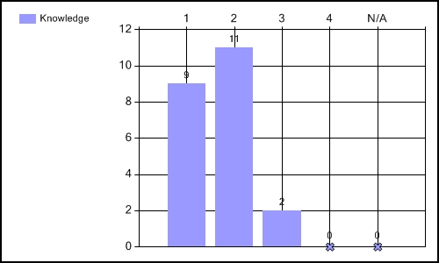

3. Demonstrated the belief that children can learn/develop. (Employer Survey Q. 2)

1=Exemplary | 2=Proficient | 3=Basic | 4=Unsatisfactory

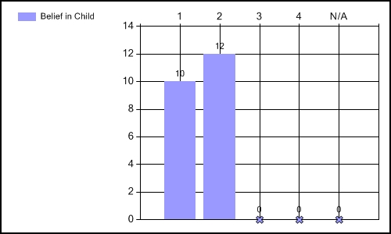

4. Planned effectively to meet objectives. (Employer Survey Q. 3)

1=Exemplary | 2=Proficient | 3=Basic | 4=Unsatisfactory

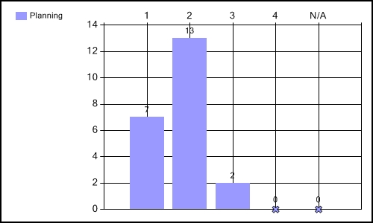

5. Positively impacted student learning. (Employer Survey Q. 4)

1=Exemplary | 2=Proficient | 3=Basic | 4=Unsatisfactory

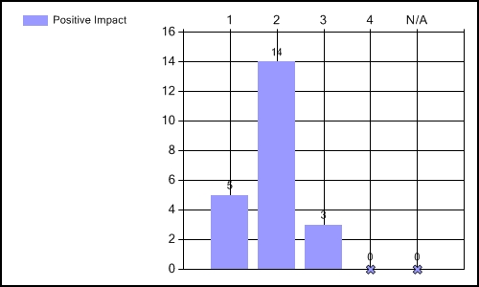

6. Created a caring and supportive environment. (Employer Survey Q. 5)

1=Exemplary | 2=Proficient | 3=Basic | 4=Unsatisfactory

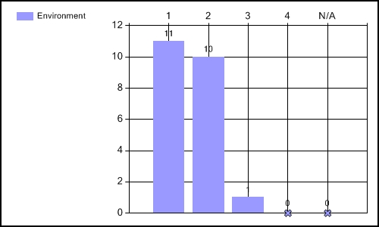

7. Followed school and professional rules, standards, and regulations.
(Employer Survey Q. 6)

1=Exemplary | 2=Proficient | 3=Basic | 4=Unsatisfactory

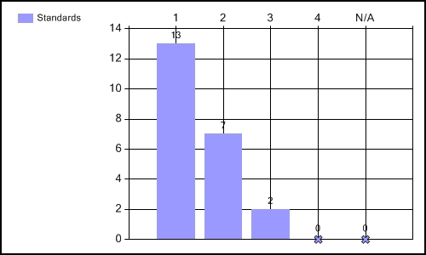

8. Took part in faculty development and other opportunities to grow professionally.
(Employer Survey Q. 7)

1=Exemplary | 2=Proficient | 3=Basic | 4=Unsatisfactory

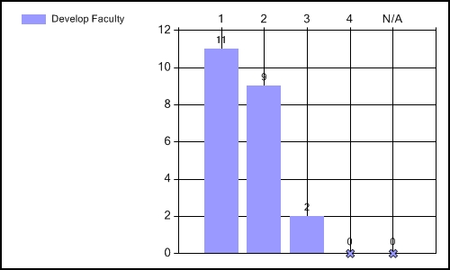
9. Employed effective classroom management techniques.
(Employer Survey Q. 8)

1=Exemplary | 2=Proficient | 3=Basic | 4=Unsatisfactory

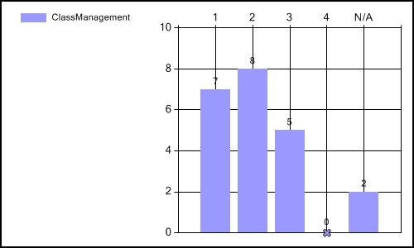
10. Created activities adapted for students with diverse cultural backgrounds and exceptionalities.
(Employer Survey Q. 9)

1=Exemplary | 2=Proficient | 3=Basic | 4=Unsatisfactory

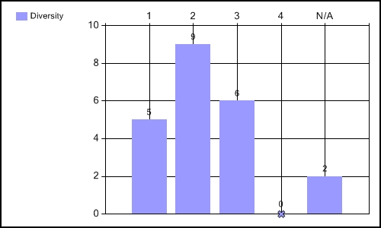
11. Used technology to facilitate student growth.
(Employer Survey Q. 10)

1=Exemplary | 2=Proficient | 3=Basic | 4=Unsatisfactory

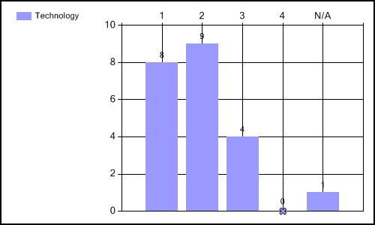

12. Integrated other related subjects into his/her curriculum.
(Employer Survey Q. 11)

1=Exemplary | 2=Proficient | 3=Basic | 4=Unsatisfactory

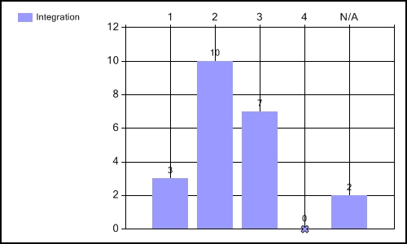

13. Demonstrates organizational skills fitting of his/her position.
(Employer Survey Q. 12)

1=Exemplary | 2=Proficient | 3=Basic | 4=Unsatisfactory

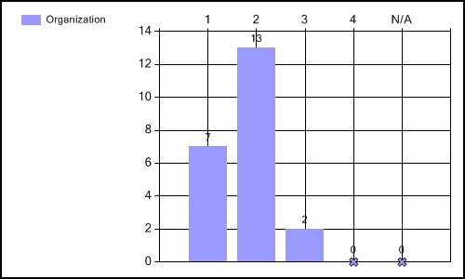

14. Understands and cultivates collaboration, collegiality and teamwork.
(Employer Survey Q. 13)

1=Exemplary | 2=Proficient | 3=Basic | 4=Unsatisfactory

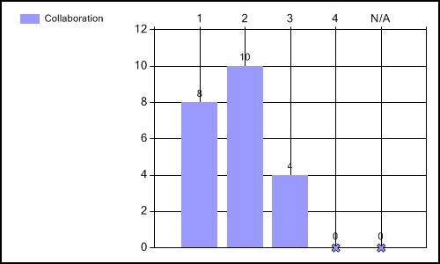

16. I am generally satisfied with OSU's teacher and counselor education graduates.
(Employer Survey Q. 15)

1=Exemplary | 2=Proficient | 3=Basic | 4=Unsatisfactory



