

Results of the Employer Feedback Survey

MS & PhD with a Major in Counseling

Table of Content

Overview Page 3
Procedures and Response Rate Page 3
Results Page 3
Results: Q1-Work Setting Page 5
Results: Q2-Highest Degree Page 6
Results: Q3-Skills: General Counseling Page 7
Results: Q4-Skills: Testing/Assessment Page 8
Results: Q5-Skills: Consultation & Referral Page 9
Results: Q6-Skills: Open to & makes use of supervision Page 10
Results: Q7-Skills: Instruction/Teaching/Presenting Page 11
Results: Q8- Knowledge Base: Counseling Theories Page 12
Results: Q9- Comportment: Demonstrates Ethical Behavior Page 13
Results: Q10-Comments Page 14

Overview

Drawing on the employer surveys used in the previous self-study, the CACREP writing team (Drs. Dykeman and Stauffer) constructed a survey that could be administered to the employers of both MS and PhD graduates. The writing team decided to employ an online survey methodology utilizing the online survey software run by OSU’s College of Business (see https://surveys.bus.oregonstate.edu/BsgSurvey2_0/main.aspx?SurveyID=1730&cmd=survey).

The survey assessed the following areas: (1) Skills: General Counseling, (2) Skills: Testing/Assessment, (3) Skills: Consultation & Referral, (4) Skills: Open to & makes use of supervision, (5) Skills: Instruction/Teaching/Presenting, (6) Knowledge Base: Counseling Theories, and (7) Comportment: Demonstrates Ethical Behavior. The respondents assessed their employees in each area using the following partially anchored likert scale: 5 Clearly Excellent, 4, 3 Clearly Adequate, 2, 1 Clearly Deficient. In addition, respondents could add comments if they desired.

Procedures and Response Rate

The writing team culled the College of Education’s database for graduates who listed a private email address. This list was supplemented by faculty knowledge of private emails. The total number of graduates with such emails was 83. These graduates were then email and requested to forward the URL of the survey to their employer. A total of 44 emails were returned as undeliverable leaving a potential n for this evaluation at 39. There were 15 responses from employers for a total response rate of 38.46%.

Results

The employer-respondents came from graduates of both the PhD (n=6) and MS (n=9) programs. The graduates worked in school (n=5), community (n=4), higher education (n=3) and other settings (n=3).

The mean score for the six assessment items ranged from 4.1 to 4.7. The mean for all six items fell closer to the “Clearly Excellent” anchor than any other.

Eight respondents left comments. Comment #1 reflects regrettable fallout from personnel resignations and medical leaves. Fortunately, this turnover was unusual and the communication problem mentioned should resolve itself as suggested by the commenter. Comment #8 about the need for more family therapy training mirror informal conversations of the CAU faculty. In the Spring quarter of 2008 the faculty plans to discuss ways to integrate more family therapy training into the curriculum.

Appendix: Individual Items

Question #1:
Your Work Setting (Please check one)
- K-12 Schools
- Community Agency
- Higher Ed
- Private Practice
- Other

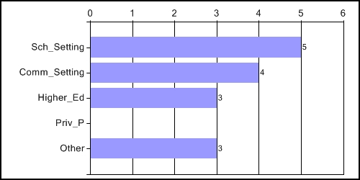

Question #2:
Highest Degree of Your OSU Counseling graduate-employee (please check one)
- MS
- PhD

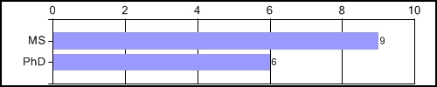

Question #3:
Please rate your OSU Counseling graduate-employee on: Skills-General Counseling
5 Clearly Excellent
4
3 Clearly Adequate
2
1 Clearly Deficient

= 4.6

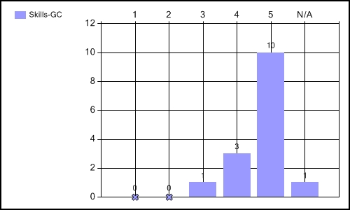

Question #4:
Please rate your OSU Counseling graduate-employee on: Skills: Testing/Assessment
5 Clearly Excellent
4
3 Clearly Adequate
2
1 Clearly Deficient

= 4.1

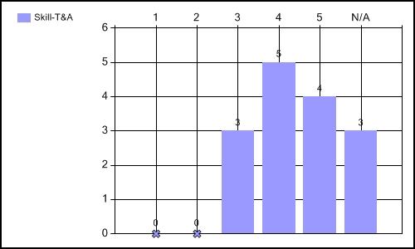

Question #5:
Please rate your OSU Counseling graduate-employee on: Skills: Consultation & Referral
5 Clearly Excellent
4
3 Clearly Adequate
2
1 Clearly Deficient

= 4.2

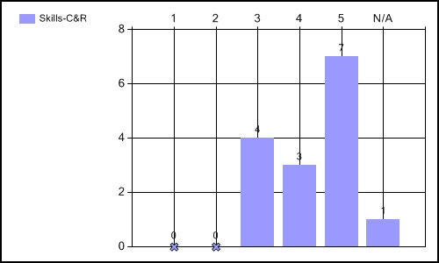

Question #6:
Please rate your OSU Counseling graduate-employee on: Skills: Open to & makes use of supervision
5 Clearly Excellent
4
3 Clearly Adequate
2
1 Clearly Deficient

= 4.5

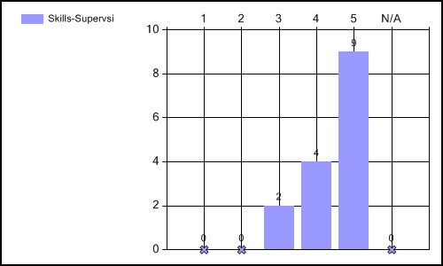

Question #7:
Please rate your OSU Counseling graduate-employee on: Skills: Instruction/Teaching/Presenting
5 Clearly Excellent
4
3 Clearly Adequate
2
1 Clearly Deficient

= 4.3

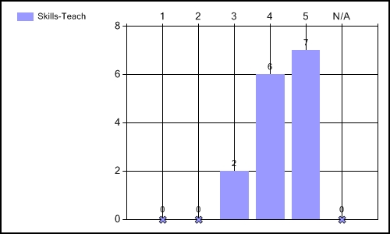

Question #8:
Please rate your OSU Counseling graduate-employee on: Knowledge Base: Counseling Theories
5 Clearly Excellent
4
3 Clearly Adequate
2
1 Clearly Deficient

= 4.5

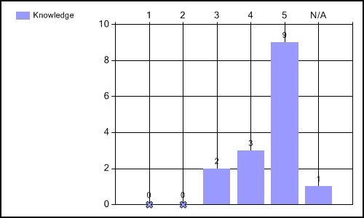

Question #9:
Please rate your OSU Counseling graduate-employee on: Comportment: Demonstrates Ethical Behavior
5 Clearly Excellent
4
3 Clearly Adequate
2
1 Clearly Deficient

= 4.7

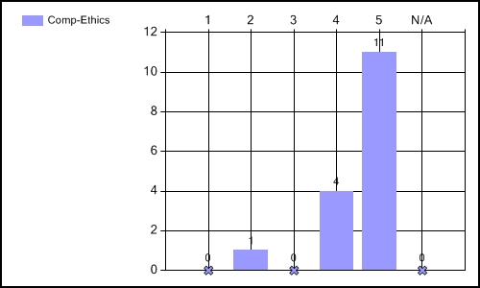

Question #10:

Comment #1: This may not be much of a suggestion, but I hope the department can stop going through changes. There's been a partially revolving door and I think that's hurt communication just a little. I know one person from our organization who has contacted three profs about trying to get some info about the program and hasn't had a response from any of the three... Knowing you to be a responsive, helpful group, I'm guessing you're under to much stress and/or dealing with too many changes, or something... I've always enjoyed working with the counseling program and I hope that all goes well. You are a very, very important part of the the counseling community in our state and your continued leadership is needed.

Comment #2: GET MORE STUDENTS LIKE CYNDI BRIGGS! SHE'S TERRIFIC.

Comment #3: This counseling graduate is knowledgeable and receptive to coaching. I beleive she feels she would benefit from a greater focus on college planning and entrance requirements. I am very pleased to have her as part of our team.

Comment #4: Our counselor came very well prepared. Her social service background has been an asset. These days counselors are put into the pre-referral process for Sped more frequently. Having a firm grasp of this role with some authentic background experiences would be a helpful asset.

Comment #5: I have no suggestions at this time. The counselor I have from your program does an excellent job for me. She goes above and beyond what I would expect.

Comment #6: I'd like to compliment you on having a first rate program. We see many applicants with Counselor Education backgrounds and your student was among the best trained in our selection pools. If Motoko Nakazawa-Hewitt is representative of the program, we ask that you educate more!

Comment #7: This employee does not work in counseling. Not sure if this helps you or not.

Comment #8: More training in family therapy.

